**Acceptable Dating Age Estimator:**

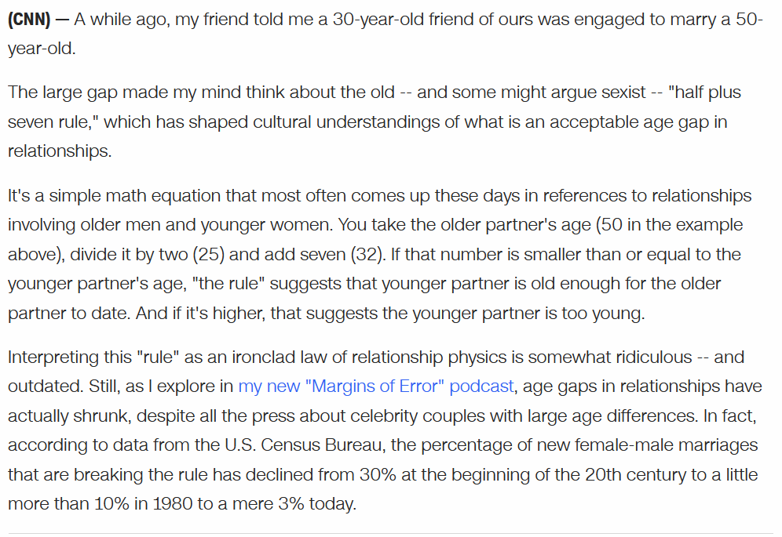

Sourced from: <https://www.cnn.com/2021/10/19/politics/harry-enten-podcast-margins-of-error-age-gaps-in-marriage/index.html>

Source Code:

DATING_ACCEPTABLE_AGE = 14.5

#1 Get 2 ages of partners:

fPerson1 = float( input("What is person 1: ") )

fPerson2 = float( input("What is person 2: ") )

# Determine of morally acceptable age:

if fPerson1 < DATING_ACCEPTABLE_AGE or fPerson2 < DATING_ACCEPTABLE_AGE:

print("One or both of the persons is less than", DATING_ACCEPTABLE_AGE)

print("No way are we doing this.")

raise SystemExit

#2 Determine the lowest acceptable age:

if fPerson1 == fPerson2:

print("The ages are equal so have fun!")

raise SystemExit

if fPerson1 > fPerson2:

fOlder = fPerson1

fYounger = fPerson2

else:

fOlder = fPerson2

fYounger = fPerson1

#3 Find the lowest accdeptable age:

fLowestAgeAcceptable = (fOlder / 2) + 7

#4 Logical Compare

if fYounger >= fLowestAgeAcceptable :

sMessage = "Someone is younger but the age gap is OK"

else:

sMessage = "No way...too young...find someone else"

#4 Output results

print("The older age is:", fOlder)

print("The younger age is:", fYounger)

print("The absolute lowest age to date is:",fLowestAgeAcceptable)

print(sMessage)